## JS Back-End Exam – Real Estate Agency

## Exam Rules:

1. You have **4 hours**
2. When you are ready, delete the ***node_modules***folder, make sure all dependencies are listed in the ***package.json*** file and submit your archived project.
3. You are provided with **HTML & CSS** resources
4. You may **add attributes** (such as **class** and **dataset**), but it is forbidden to **change** **existing** attributes (such as **class** and **id**)
5. You may **change "href"** attributes on links and add/change the **method** and **action** attributes of HTML Forms.
6. Use **Express.js** as a back-end framework
7. Use **MongoDB** as a database with [**mongoose**](https://mongoosejs.com/docs/)
8. You can use whatever **view engine** you like ([**express-handlebars**](https://www.npmjs.com/package/express-handlebars), EJS, Pug etc.…)
9. Use [**bcrypt**](https://www.npmjs.com/package/bcrypt) **for hashing the password**
10. The application **must start** from file **"index.js"** on port **3000**
11. It is **forbidden** to **use** **React**, **Vue**, **Angular** etc.

## Application Overview

Get acquainted with the provided **HTML and CSS** and create an application for a **real estate agency**.

The visitors can **view** the **Home page** and **Housing for rent** catalog with available offers, they can also **register** with a **name**, **username**, and **password**, which will allow them to create their **own offers** for housing, **rent a home**(if the **current user** is **not** the **owner of the housing** offer and if there **are vacant housing**). Authors can edit or delete posts at any time.

## Functional Requirements

### Guest (not logged in)

**Guest** navigation example:



The **application** should provide Guest (not logged in) users with the functionality to login, register, **view** the Home page, **Housing for rent** page and the **Details** page.

### Users (logged in)

**User** navigation example:



The **application** should provide **Users** (logged in) with the functionality to:

* **View Home page and all other pages with logged-in navigation**
* **View Housing for rent**
* **Create а new housing offer [Create Offer]**
* **Access housing details page [Details]**
* **Renting a home (**if the **current user** is **not** the **owner of the housing** offer and if there **are vacant housing)**
* **Delete or Edit housing depending on user's authentication (only for owner of the current offer for housing)**

## Database Models

The **Database** of the **Real Estate Agency** application needs to support **2 entities**:

### User

* Name - string (required),
* Username - string (required),
* Password - string (required)

### Housing

* **Name - string (required),**
* **Type - string (*“*Apartment”, “Villa”, “House”) required,**
* **Year - number (required),**
* **City – string (required),**
* **Home Image - string (required),**
* **Property Description - string (required),**
* **Available pieces - number(required)**
* **Rented a home - a collection of Users (reference to the User model)**
* **Owner - object Id (reference to the User model)**

**Note:** When a user **rents a home**, their **id** is added to that collection (**Rented a home**)

Implement the entities with the correct data types.

## Application Pages (80 pts)

**Home Page (For logged in users and logged-out users)**

Visualize the **last 3 added housing offers**. Each offer must show information about the **home Image**, the **name**, as well as a page with **details** about the **specific housing** (the **[Detail] button** will be visible when the **mouse cursor** reaches the image of the **housing**).

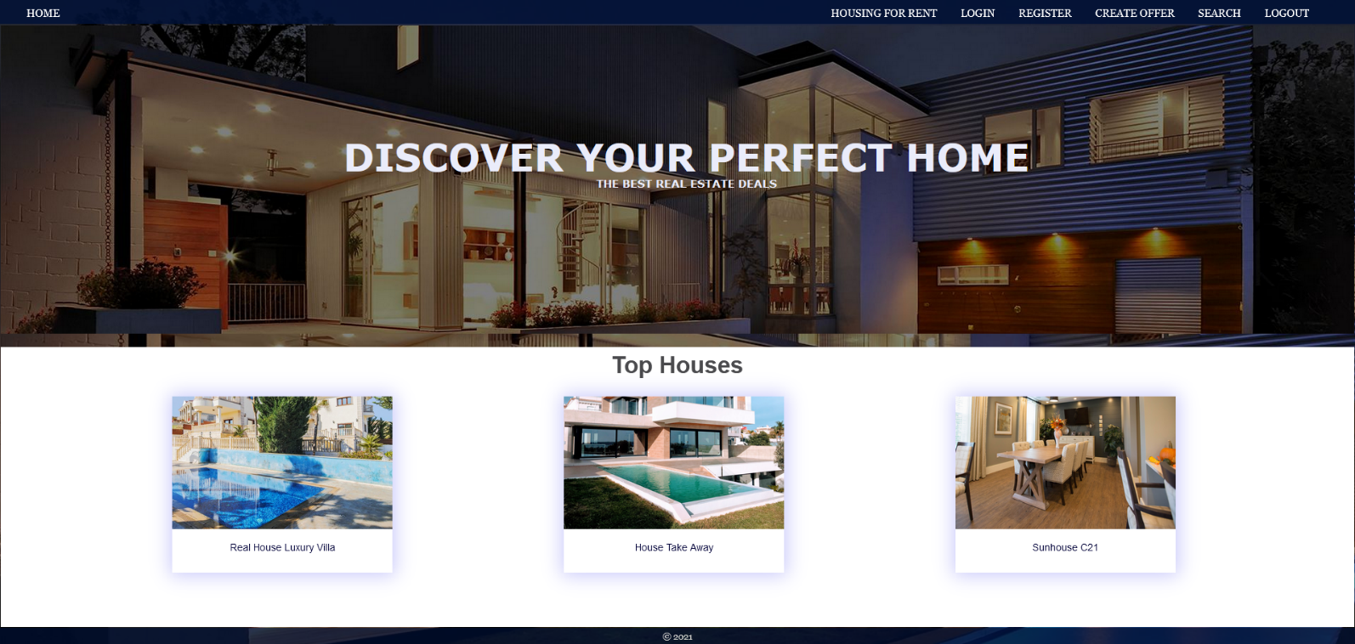

If there are **NO** housing offers in the database yet, display **"There are no housing offers found…"**

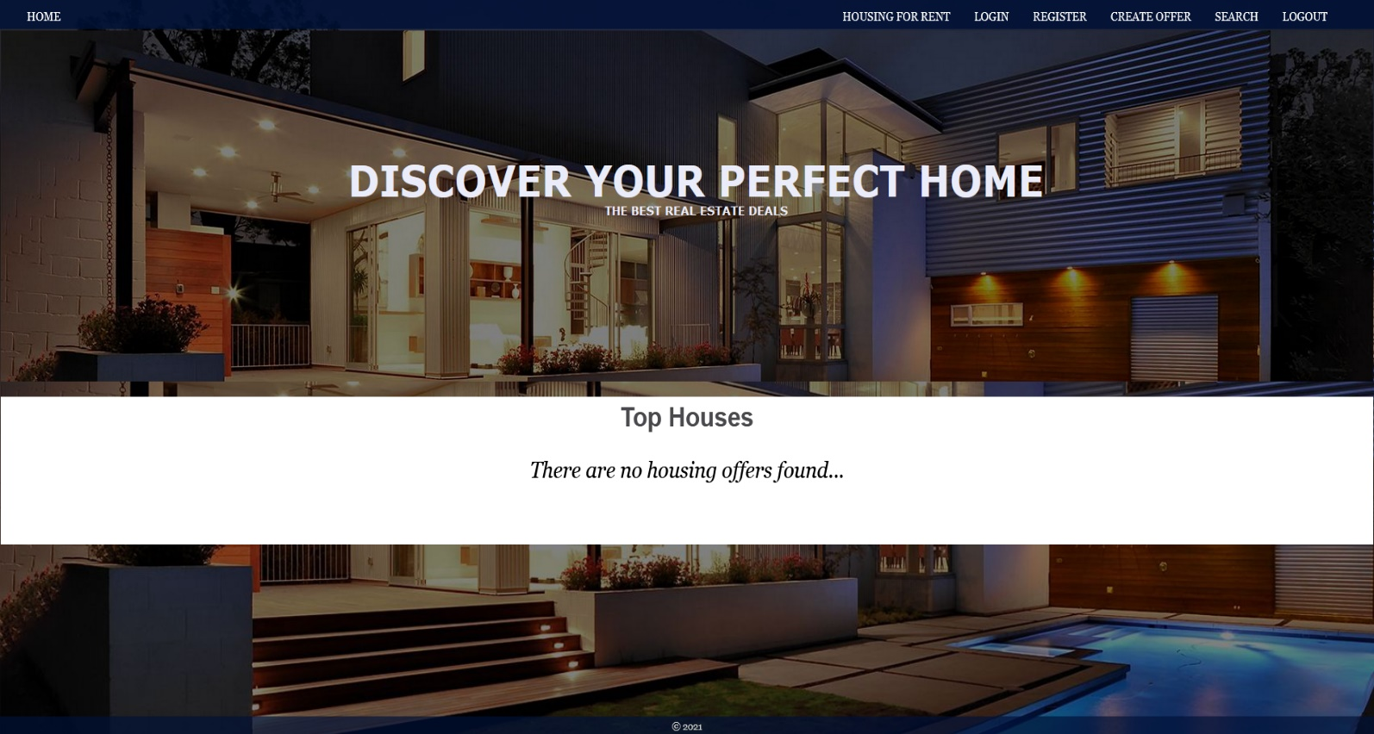

**Register Page (Logged Out User)**

**Register** a user inside the database with **name, username, and password**. **Password** inside the **database** must be hashed (**use bcrypt**) and both passwords **must match**! After successful registration, you should **redirect** to **Home page**.

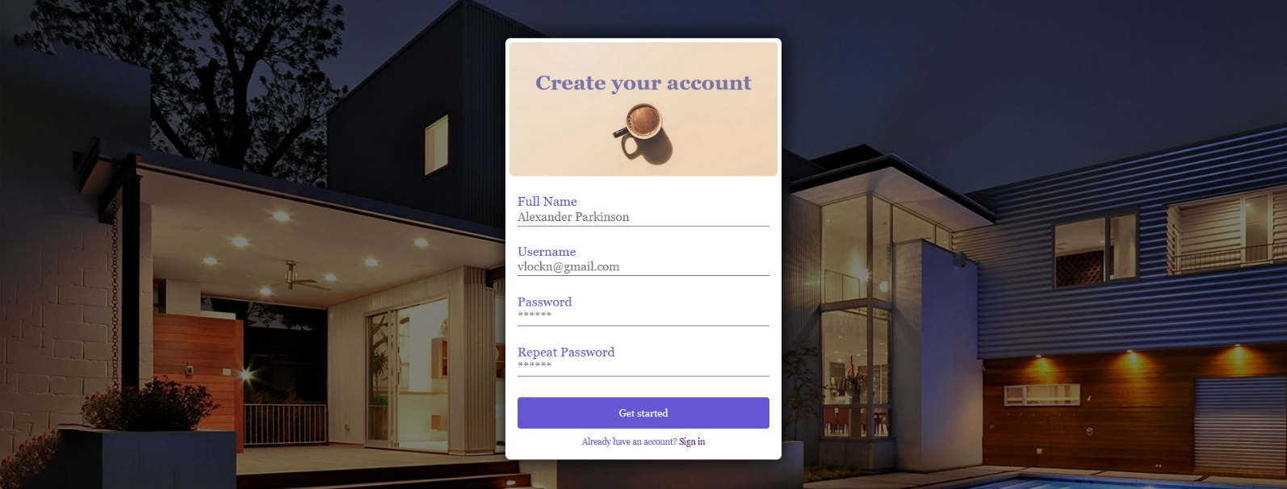

**Login Page (Logged Out User) - (5 Pts)**

Logging an already registered user with the correct **username** and **password**. After successful login, you should **redirect to Home page.**



#### Logout (logged in user)

The logout action is available to **logged-in** users. Upon success, clear any session information and **redirect** the user to **Home** page.

#### Housing for rent (For logged in users and logged out users)

List all housing offers. Each home must display information about the **home Image**, the **name**, the **description**, as well as a page with **details** about the **specific housing** (the **[Detail] button** will be visible when the **mouse cursor** reaches the image of the **housing**). As in the picture below:

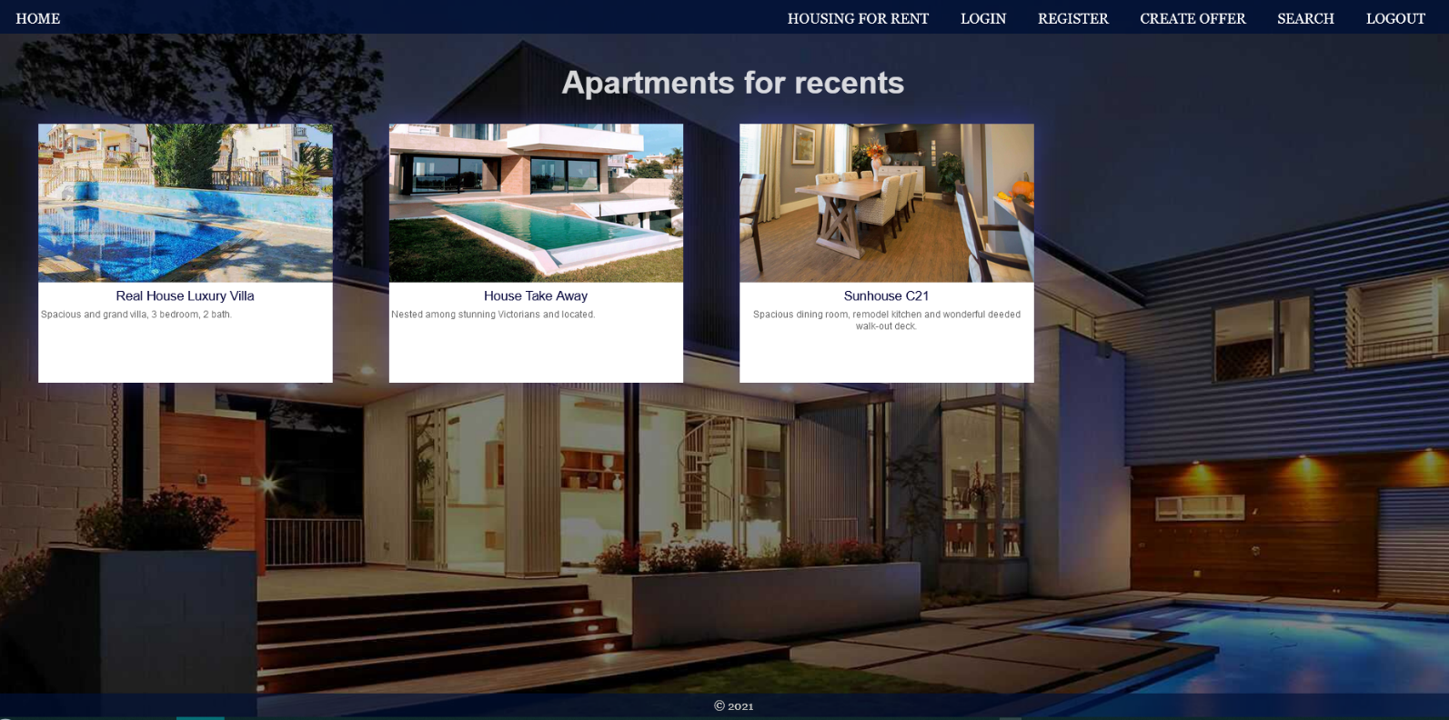

[**Details**] button should be a link to the **details** **page** for the current home.

If there are **NO** housing offers in the database yet, display **"There are no housing offers found... "**

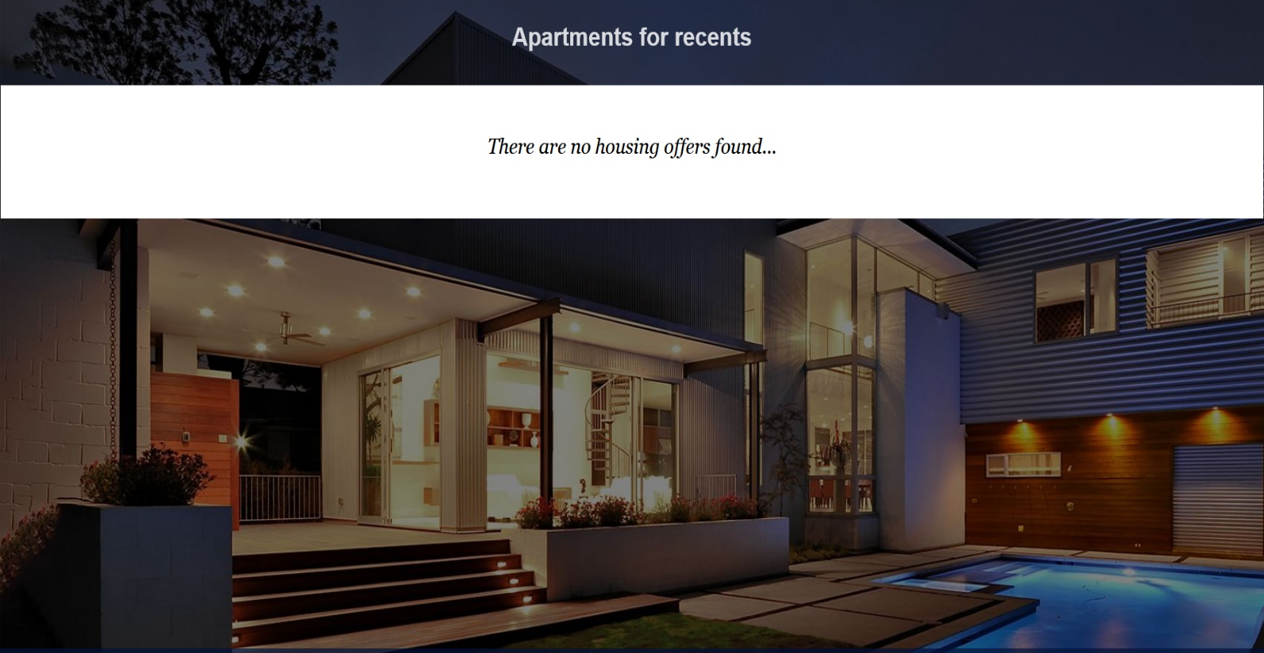

**Details Page - (for logged in users and logged out users)**

All users should be able **to see details** of the home. Clicking the **Details button** in the housing card should display the details page. If the currently registered user **is the creator** of the housing offer, the **Edit** and **Delete** buttons should be displayed, otherwise they **should not be available**.

Information about the housing:

* **Name**
* **Type**
* **Year**
* **City**
* **Home Image**
* **Description**
* **Available pieces**
* **People rented this housing**
  + If any, separate their names with **comma** and **space** ", "
  + If not, display **"There are no tenants yet.**
* **Buttons** (Depending the status of the currently logged in user)

#### Details Page (logged out users)

If there are **no logged** in user, **no buttons** should be displayed.

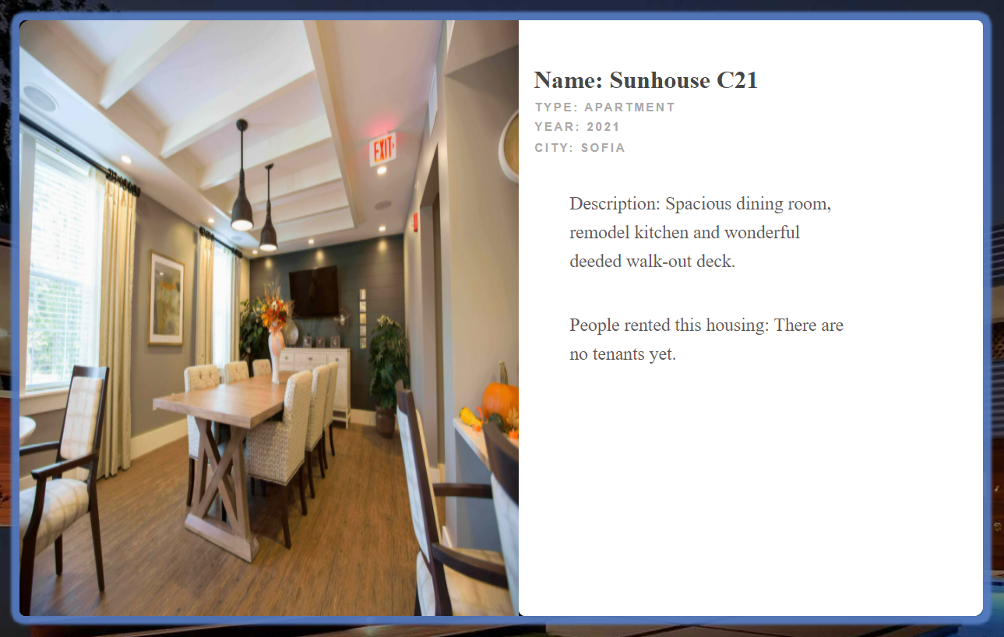

#### Details Page (logged in user and creator of the current offer)

If the **currently logged-in** user is the **owner** (the user who **created the home offer**), he should see the **[Delete]** and **[Edit]** buttons.

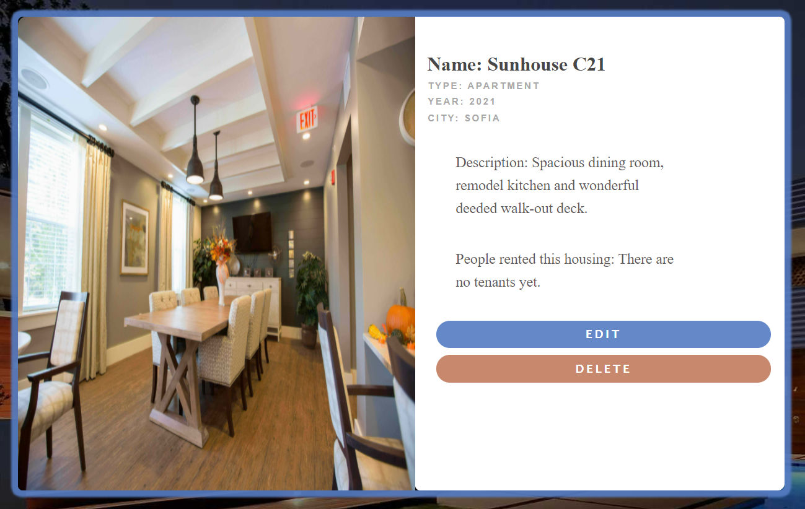

#### Details Page (logged in user with available places)

If the currently logged in user is **not the owner** (a user who is not the creator of this housing offer) and has not rented that housing, he should see a button like [**Rent a home, available** **{available pieces} housing**]. If there is at least 1 place left.

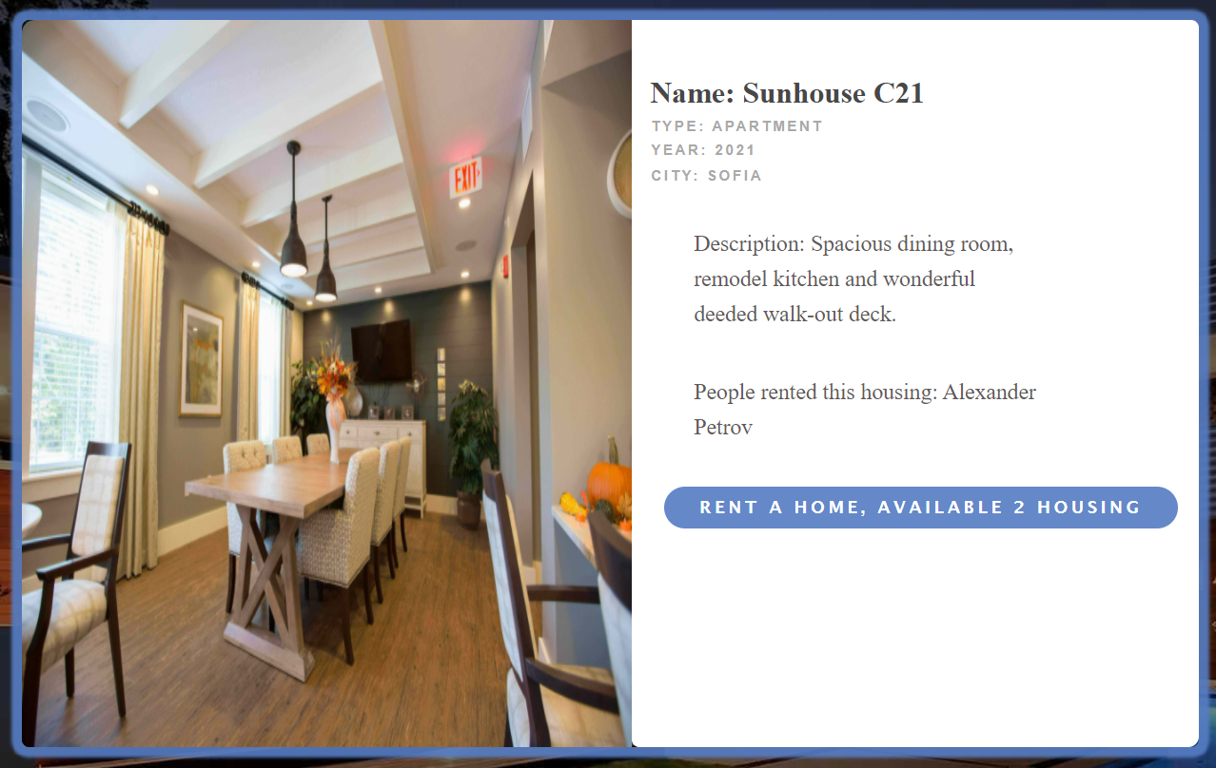

#### Details Page (logged in user already rented this housing)

If the currently logged in user **is not the owner** and has **already rented the current home**, he should see **[You have already rent this home].**

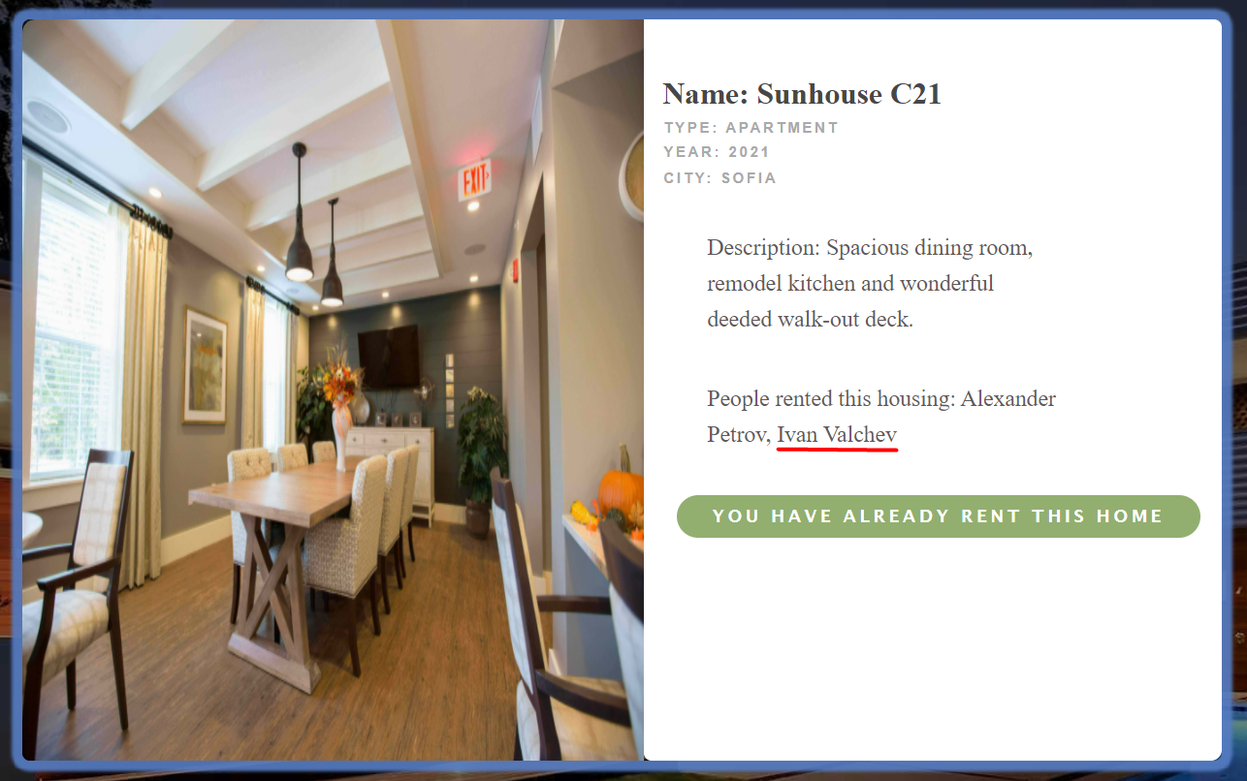

#### Details Page (logged in user with no available pieces)

If the currently logged-in user is not **the owner** and there are **no available pieces** for rent housing, he should see the [**No Housing Available!**].

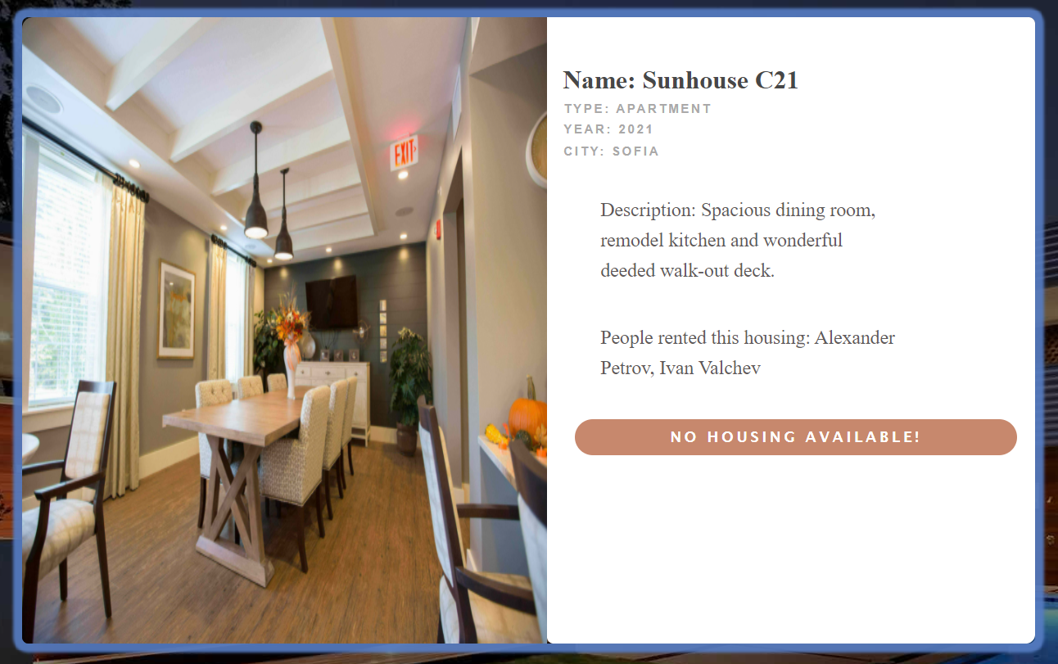

#### Rent Housing (logged in user which is not the current housing owner)

Any registered user who is **not** the current **owner** of the housing offer must be able **to rent a home** (if any).

If he manages to **rent successfully** the housing, his **userId** must be added to the collection of **Rented a home**, and the available pieces should be **reduced** **by** **1** and **redirect** the user to the **Details** page for the current **housing offer**.

Then in the list-**People have rented this apartment**, the names of the tenants should be displayed, and the available pieces for the apartment should be reduced by 1 and redirect the user to the page with **details** of the **housing offer**.

If a user has once rented a current home, he should see "**You have already rent this home**" and in the list-**People have rented this apartment**, his name should be displayed.

If there are **no available pieces** for rent housing, he should see the "**No Housing Available!**".

**Create Offer (Logged in User)**

The **Create Offer** page is available to **logged-in users**. It contains a form for adding new home. Upon success, **redirect** the user to the **Housing for rent** page.

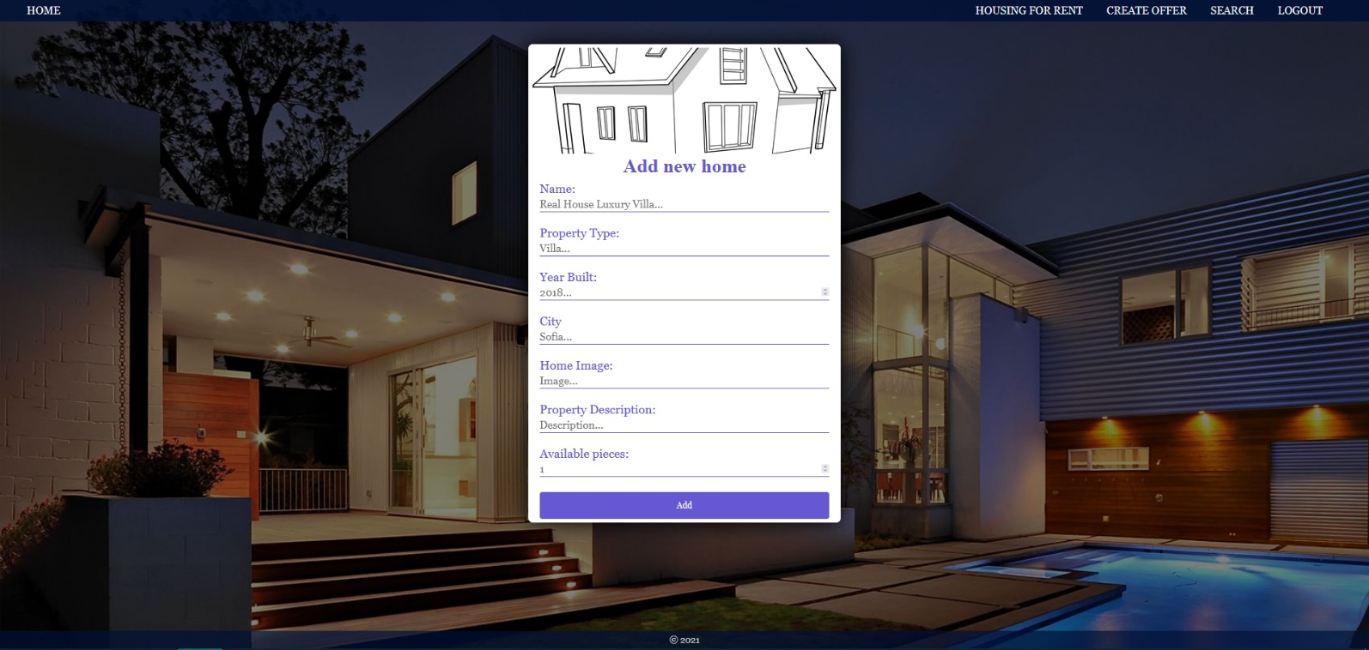

#### Delete Home (logged in user and owner of the current offer for home)

Each **owner** of the housing offer must be able to click on the **[Delete]** button and **delete the current home** from the database and the user must be redirected to the **Housing for rent** page.

#### Edit Home (logged in user and owner of the current offer for home)

Each **owner** can edit their **housing offer**. Clicking the **[Edit]** button for a specific home on the details page should display the **Edit page**, all fields being populated with housing data. It contains a form with input fields for all relevant properties. If successful, redirect the user to the **current housing details page**.

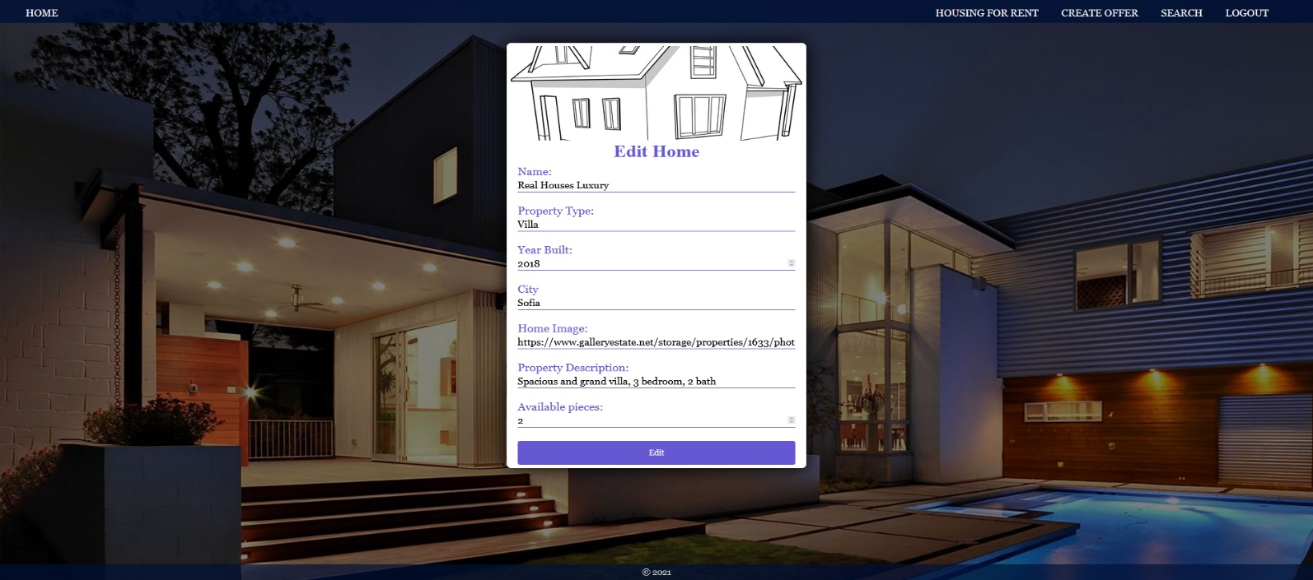

## Security Requirements (Routes Guards) - (10 Pts)

The Security Requirements are mainly **access** requirements. Configurations about which users can access specific functionalities and pages.

* Guest (not logged in) users can access Home page.
* Guest (not logged in) users can access Login page and functionality.
* Guest (not logged in) users can access Register page and functionality.
* Guest (not logged in) and Users (logged in) can access **Housing for rent** page (Listed all homes).
* Guest (not logged in) can access the **Details** page without functionality.
* Users (logged in) can access Home page.
* Users (logged in) can access Details page and functionality.
  + **Users** (not home offer owner) can **Rent a house**.
  + **Users** (home offer owner) can **Edit** and **Delete** the current home
* Users (logged in) can access **Create Offer** page and functionality.
* Users (logged in) can access Logout functionality.

Use the following view for **invalid** **paths**:

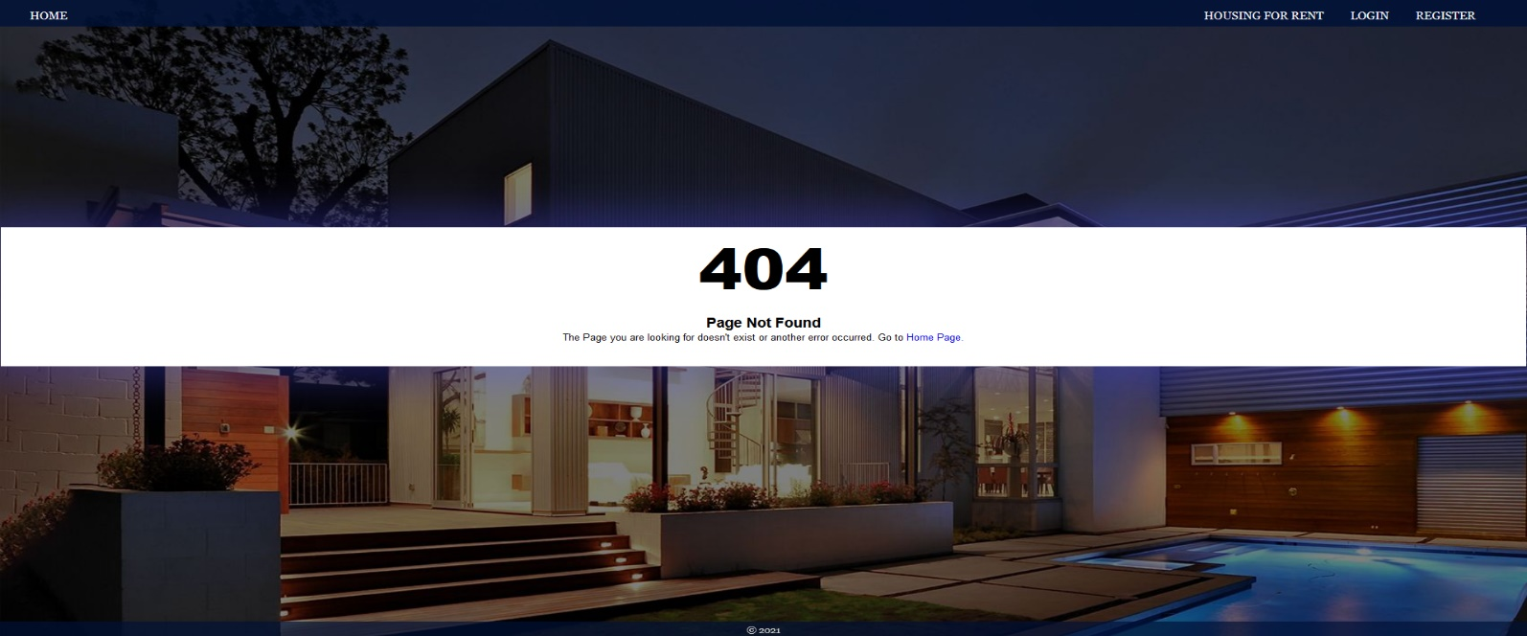

## Validation and Error Handling (10 Pts)

### The application should notify the users about result of their actions.

In case of error, you should display div with class “**errorContainer**”

### You can choose to display the first error or all of them. You have complete freedom to choose the content of the error message you will display.

### Login / Register

You should make the following validations:

* The **name** should be **in the following format ->** (firstname lastname) - "**Alexandur Petrov**"
* The **username** should be **at least** **5 characters** long
* The **password** should be **at least 4 characters** long
* The **repeat password** should be **equal to the password**

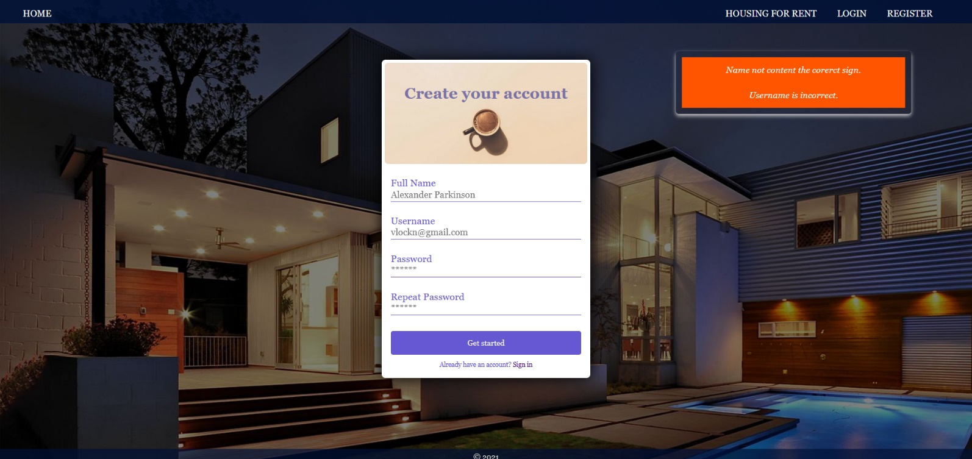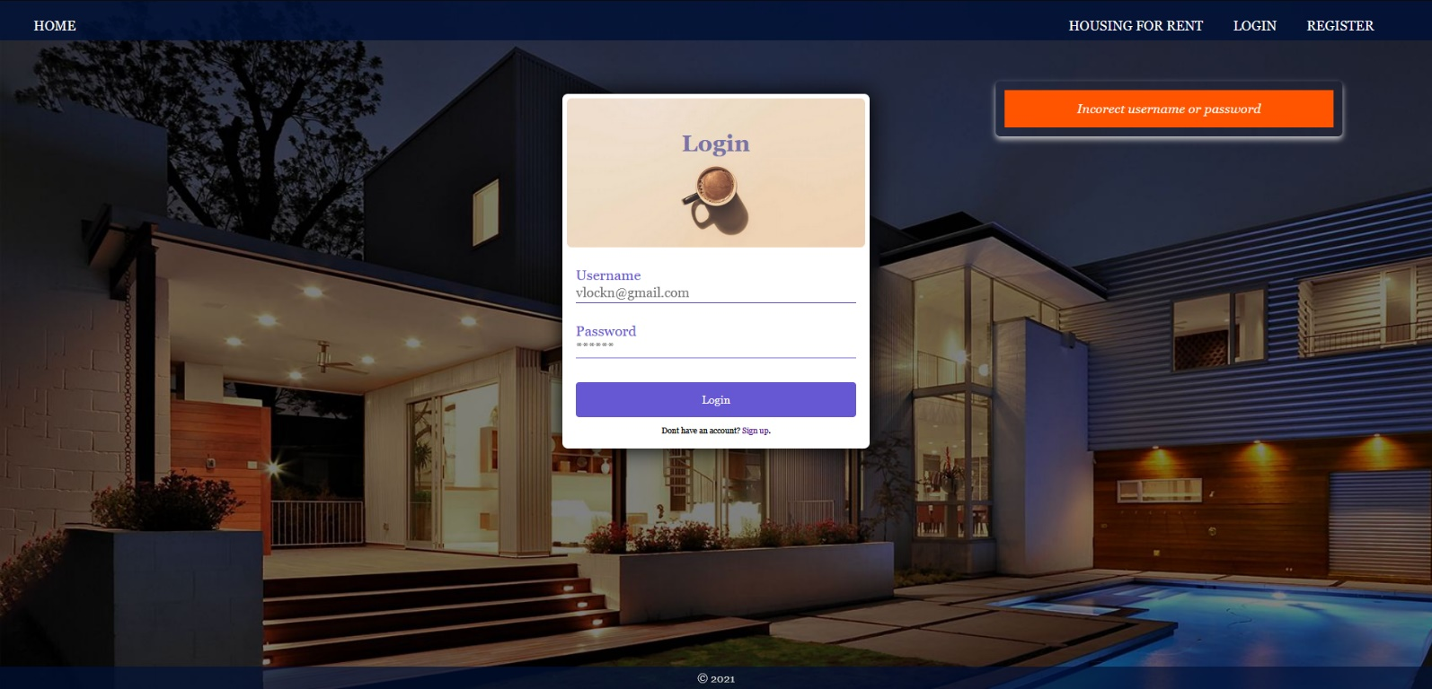

### Housing

You should make the following validations while **creating** or **editing a** **home**:

* The **Name** should be **at least 6 characters**
* The **Year** should bebetween **1850 and 2021**
* The **City** should be **at least 4 characters** long
* The **Home Image** should starts with **http:// or https://**.
* The **Property Description** should be a maximum of **60 characters** long.
* The **Available Pieces** should be positive number **(from 0 to 10)**

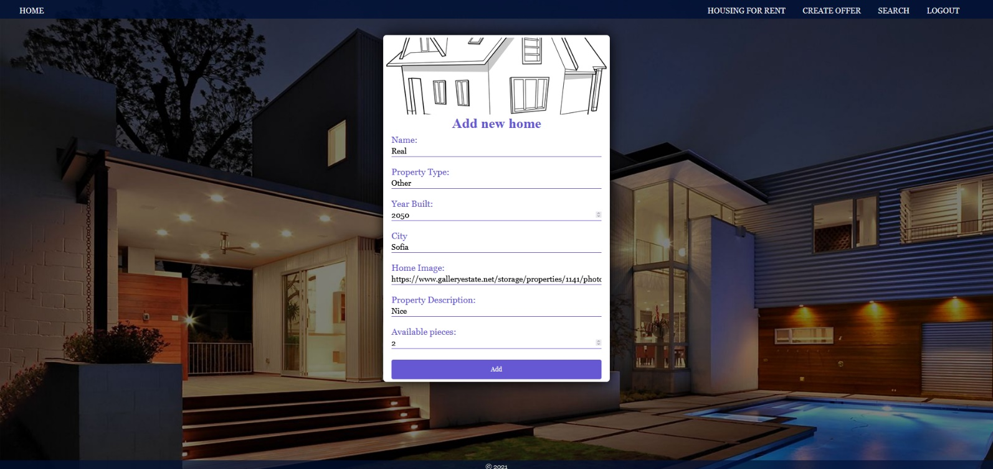

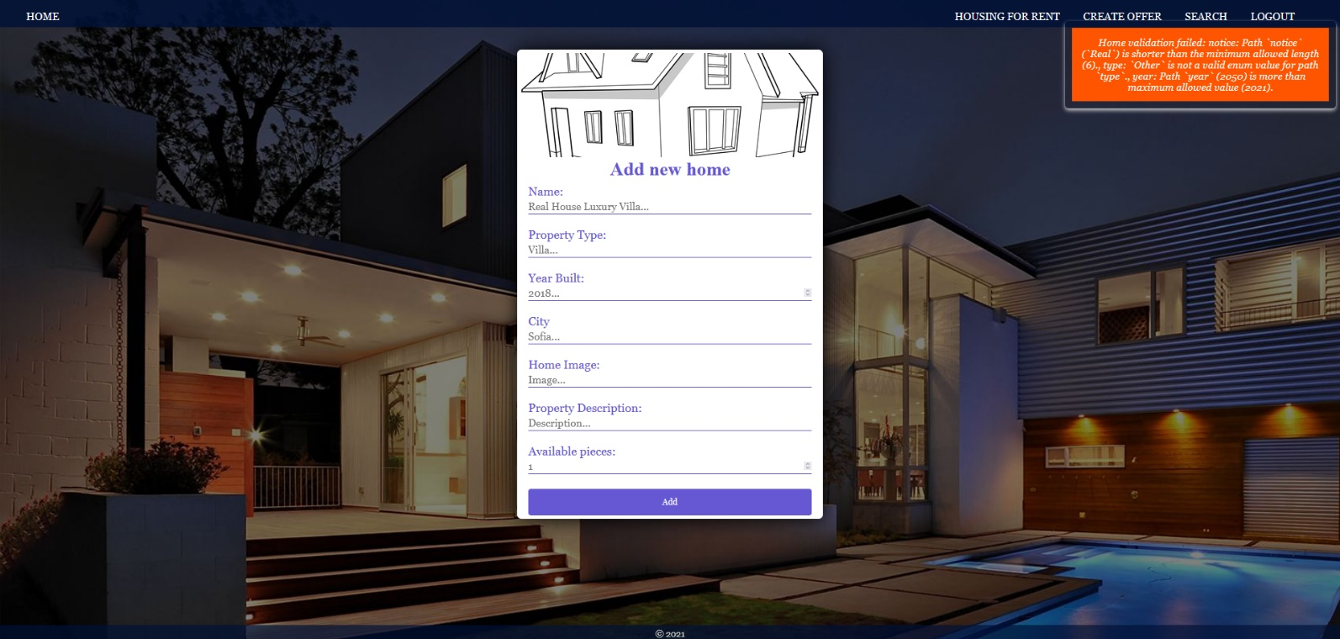

**\* Bonus – Search (10 Pts)**

Search **for housing**. Filter all **matches** by **housing type**, which includes a **search string** (case insensitive).

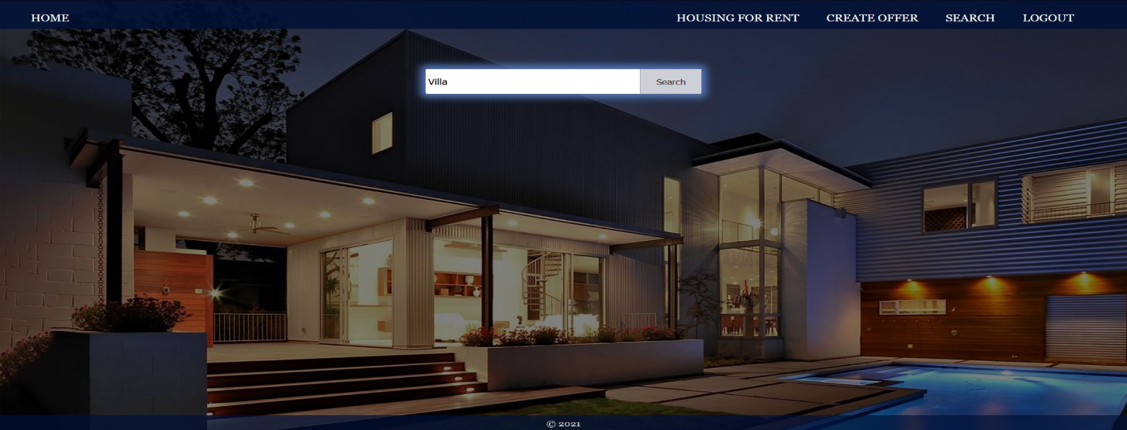

After click on **[Search]** button and If there are any matching matches from the search, show each of them.

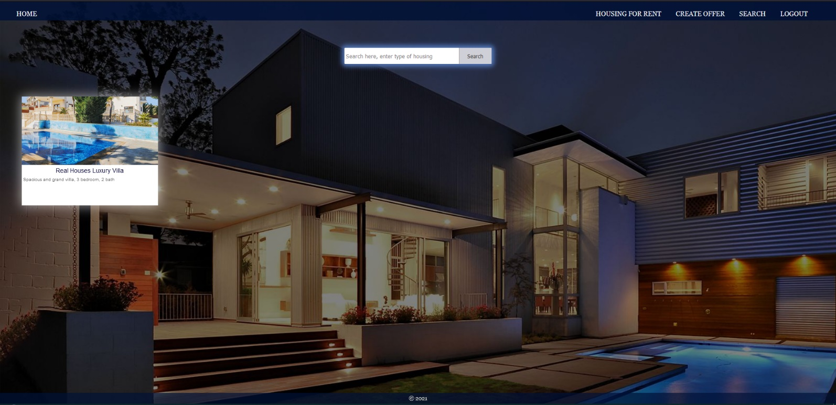

If there are **no** search matches, display:

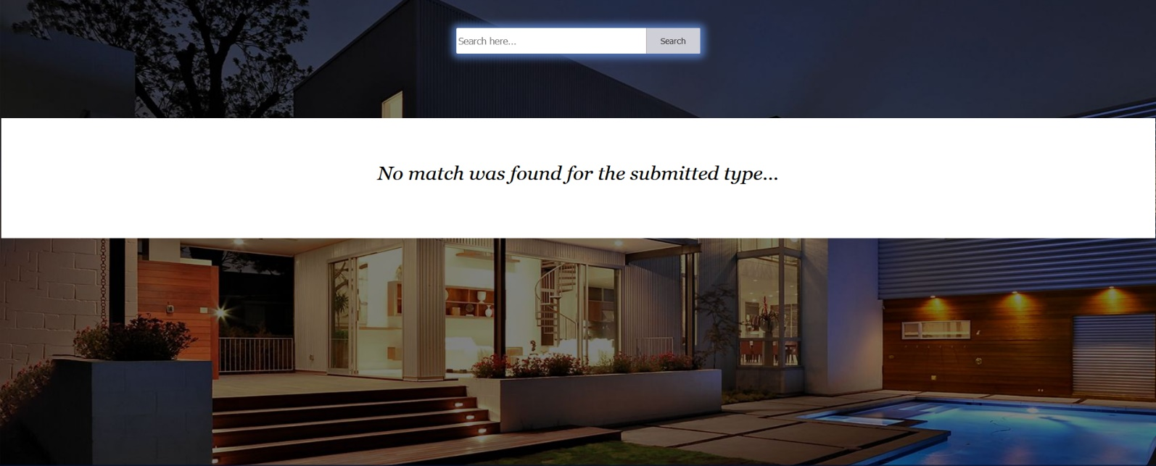

## Submitting Your Solution

Place in a **ZIP** file your project folder. Exclude the node_modules folder. Upload the archive to Judge.









*GOOD LUCK! 😊*